SIT207 Application Proposal

# Matt McInnes

## 214119048

## SIT207

# Motivation

Group assignments can be complicated in a number of ways, not only the work, but keeping track of this new group of people. Names, phone numbers, and faces all have to be remembered. With one or two people this isn’t all that challenging. The real challenge starts when you have a group with five or six members and trying to juggle all their details. That is where my application comes in. With my application we now have to ability to save and record the details of all the members in our group. We will also have to ability to view the details of the assignment.

I was motivated to build this application in hopes that I could save the time and stress of trying to memorise group members and to speed up the time that students spend on finding details for their assignments. I hope that in the future I can keep refining and adding new features to this application.

# Features

The application will have a number of useful and intuitive features.

Users will be able to add details about group members and attach a photo to the profile, done through clear and simple screens.

The application will be able to present information about the assignment to the user and open Cloud Deakin to view more information.

If the user wishes the application can add the group members into the phones address book for easy access.

The application will have the ability to view group members and their photo within the application.

Future Plans

If I were to continue this application I would add remote syncing, and more social functions to it. I would add note sharing and messaging from within the application. Unfortunately that is outside of the current scope at the moment.

# Users

The target audience of this application will be students, both in university and in high school. It can also be used for work place purposes but may have to be slightly adjusted to suit the conditions.

This application will be very user focused, as it relies on user interaction. To being the user must enter at least one group member. After that they can then browse the application.

# Interface

## Main Activity

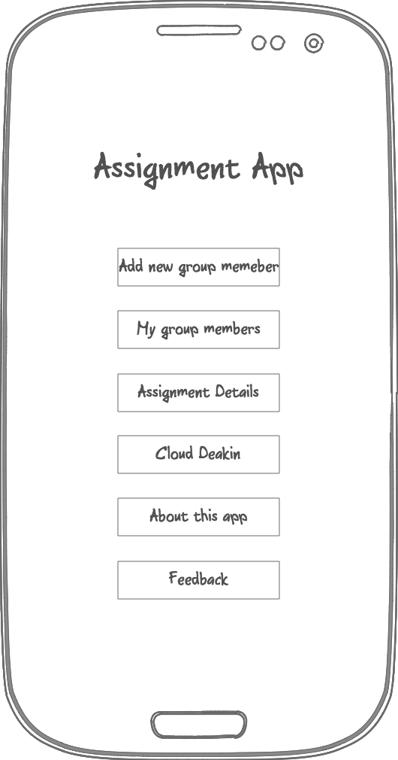

This activity is the menu activity. It provides the navigation for the application in the form of a set of clickable buttons. It will also contain the button that saves all group members to the phones contact book.

## New Profile Activity

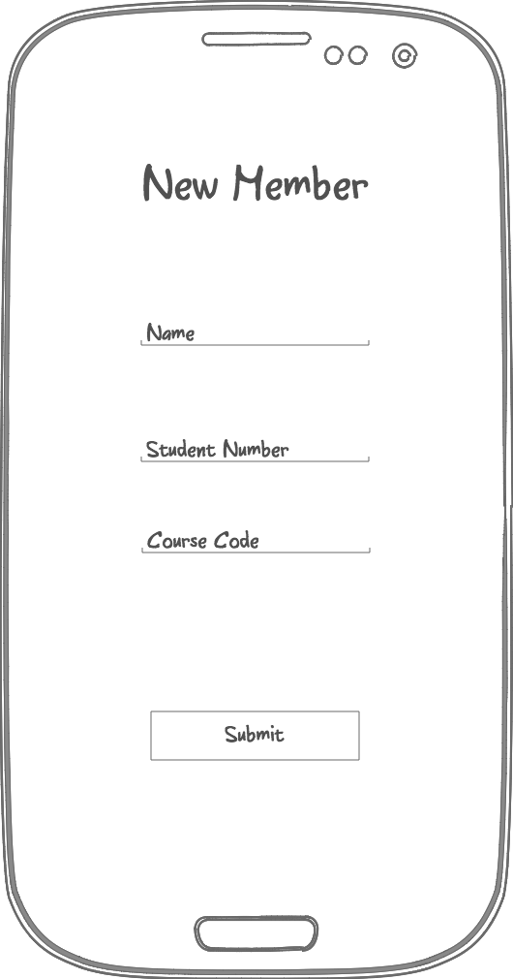

This activity allows the user to add new members to the group. This activity is shown automatically if there are no users in the database. Information is set using text inputs and a submit button. The data is taken from these inputs and saved into an sql database. After the data has been submitted to the database the user is then taken to the Camera Activity to add a photo to the profile.

# Camera Activity

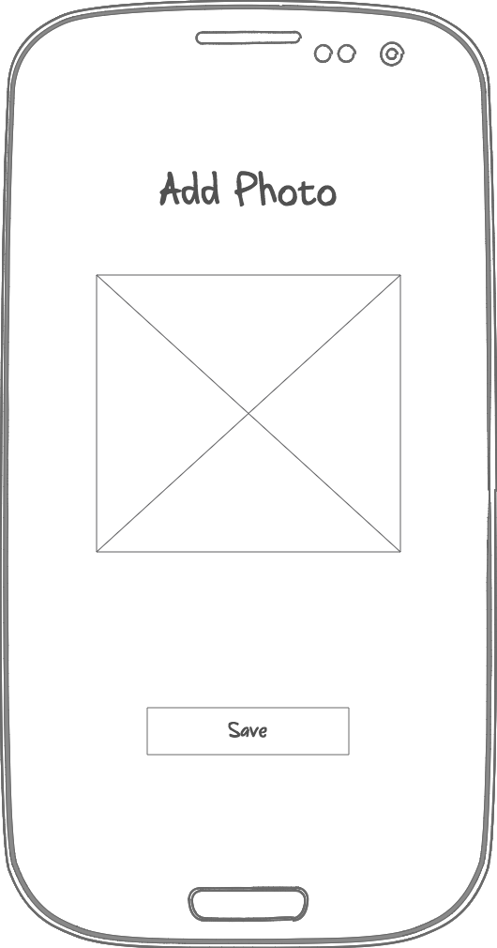

In the camera activity the user is prompted to add a photo to the profile of a group member. The photo can be added from either the phones gallery or from the camera on the device. Once a photo has been chosen and saved that database entry is updated with the file path of the photo.

# Member List

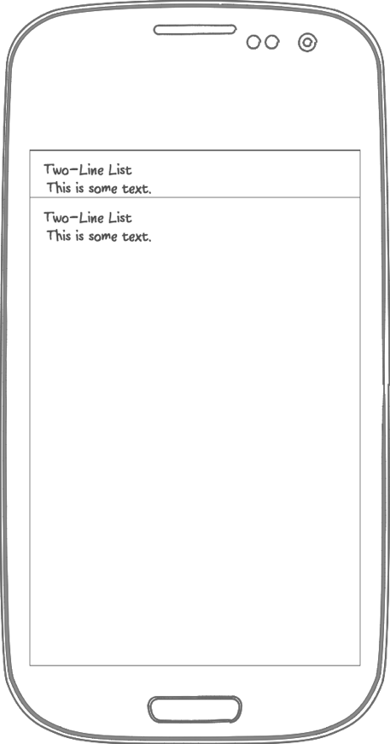

This activity contains a list view of all the members in the app. From here the user can see the name, student number, course code, and photo of the member. Data in the activity is pulled from the sql database. In this activity the user can add the group members into the phones address book.

# Assignment Information

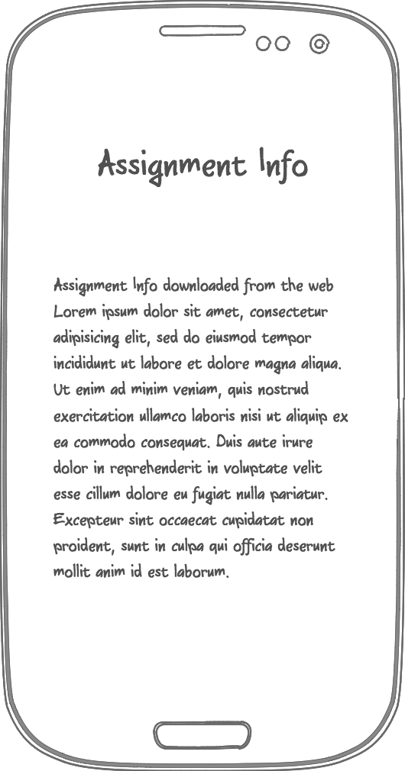

This activity shows the current assignment in a text view. The assignment information is pulled down from a web server and then parsed into a string to be displayed in the text view. The assignment details can be changed by the tutor as easily as uploading a new file containing the data to a web server. This is beneficial as assignments are often corrected or updated

# About View

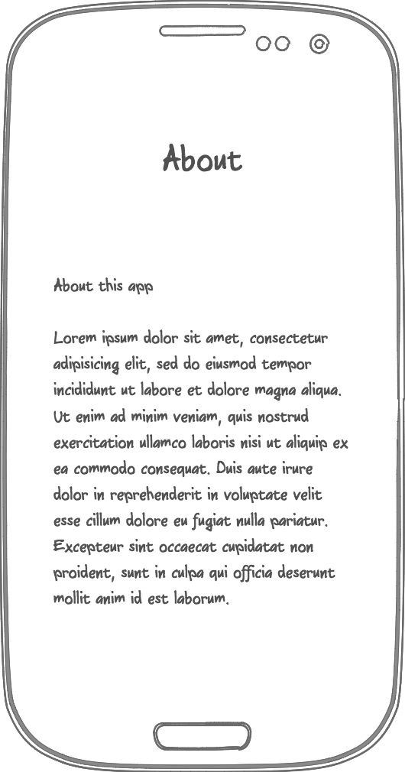

This view contains all the information about the app, such as who made it, why it was made, and a short video about how to use it.

# Feedback View

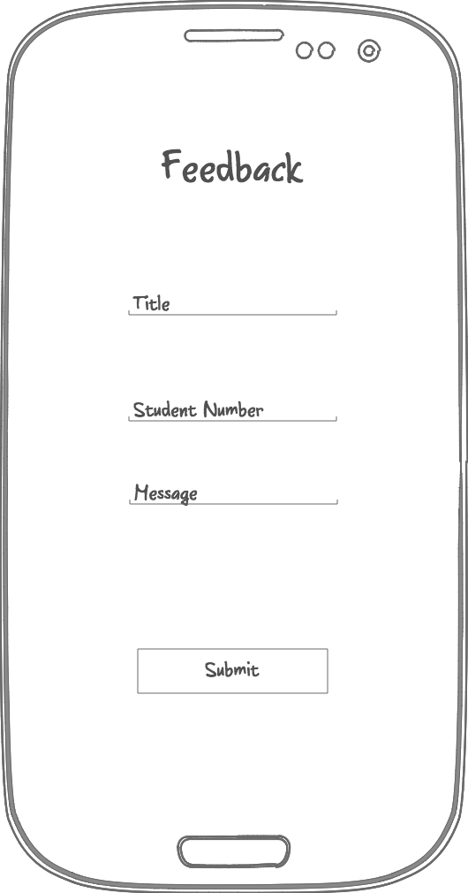

This activity allows the user to send feedback to the developer in regards to the application. The feedback contains a title, the student number of the person sending it, and the message. Data is sent to a PHP web application in the form of a json input. Data is encoded into a json file on the device and posted to the web application where is is stored in a database and emailed to the developer.